Central Tendency Analysis

Variable | Mean | Median | Mode
Engine Size | 2.005838 | 2.006399 | 1.00
Horsepower | 151.504125 | 151.141264 | 70.00
Curb Weight | 3057.937713 | 3059.902924 | 2000.00
Price | 33068.884014 | 32765.190167 | 28915.91

Descriptive Justification

1. Engine Size

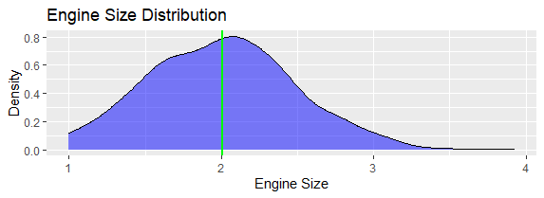
The bell curve for engine size shows the distribution of engine capacities among vehicles. The mean and median values are compared to understand the shape of the distribution.
- If the mean is close to the median, the distribution is approximately symmetric, indicating that engine sizes are evenly distributed around the average.
- If the mean is higher than the median, the distribution is positively skewed, meaning some vehicles have larger engines that increase the average.
- If the mean is lower than the median, the distribution is negatively skewed.
The curve indicates the most common engine size range and how much variation exists among vehicles.

2. Horsepower

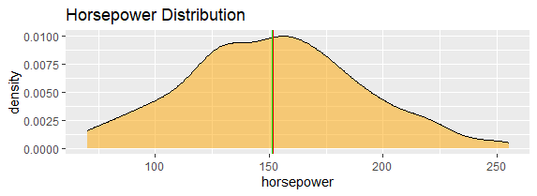
The horsepower bell curve represents the spread of engine power across vehicles.
The mean represents the average horsepower, while the median represents the middle horsepower value. A small difference between them suggests that horsepower values are relatively balanced.
A wider curve indicates greater variation in vehicle performance, while a narrower curve indicates that most vehicles have similar horsepower values.

3. Curb Weight

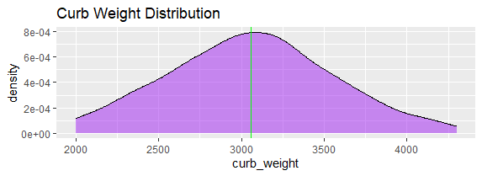
The curb weight distribution curve explains the variation in vehicle mass.
When the mean and median are close, the data suggests that most vehicles have weights near the average value. A skewed curve indicates the presence of unusually lightweight or heavyweight vehicles.
The shape of the curve helps identify whether vehicle weights are concentrated around a specific range or widely distributed.

4. Price

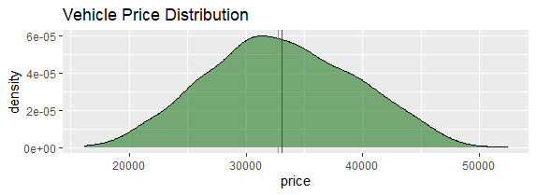
The price bell curve shows how vehicle prices are distributed.
The relationship between mean and median helps explain pricing patterns:
- A mean greater than the median indicates that some expensive vehicles increase the average price.
- A mean close to the median indicates a balanced price distribution.
- A large difference suggests price outliers.
The curve shows the typical price range of vehicles and how much variation exists between lower-priced and higher-priced vehicles.

